* **MAULANA AZAD NATIONAL INSTITUTE OF TECHNOLOGY**

**Name:** Vivek Kumar Ahirwar **Scholar No:** 191112419

**Department:** CSE **Section:**3

**Semester:** 4th **Subject:** PHP Lab

**Date:** 21/01/2020

PHP: LAB-ASSIGNMENT 1

Code:

Form.php

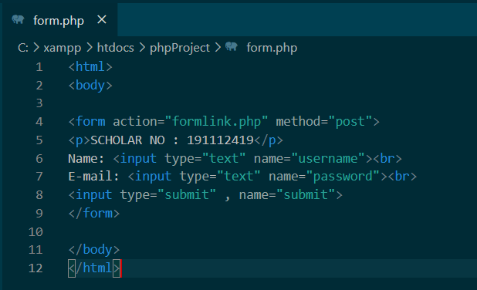

Code for:

FormLink.php

